# Module 7: Critical Thinking

Maurice Henning

Colorado State University Global

CSC500-1: Principals of Programming

Dr. Steven Evans

May 06, 2024

**Critical Thinking Assignment**

Module seven requests that I create a dictionary with course and room numbers paired to

illustrate where they meet. The following course numbers are CSC101 – 103, NET 110, and

COM241 should key-value pair with the following room numbers 3004, 4501, 6755,1244, and

1411.

Following this procedure, a dictionary should be created key pairing the previous courses with

the following instructors; Haynes, Alvarado, Rich, Burke, and Lee.

Finally, create the program with the previously mentioned course numbers with the following

meeting times; 8 am, 9 am, 10 am, 11 am, and 1 pm. In conclusion, this program should allow

users to enter the course number, then it should execute the room number, instructor, as well as

meeting time.

Step 1: First I create a comment informing the reader of an upcoming dictionary. I created the

label dictionary room_numbers and pair it with the course numbers inside brackets.

In the next line of code, I create a comment informing the reader of the next dictionary consisting

of numbers and instructors. The dictionary variable is labeled instructors and has the course

numbers associated with instructors.

The next line of function code creates a dictionary labeled meeting_times. This dictionary pairs

courses with meeting times.

Next, I create a comment informing the creation of a function to get course details. To execute

this statement I utilize the def statement short for define. This user-defined function will operate

based on my requirements. In this instance it will gather course details labeled

get_course_details. The following ‘if’ condition statement retrieves the corresponding course

number with the room number, instructor, and meeting time.

The next conditional statement ‘else’ returns nothing if no values exist.

Finally, I define the program's main section requesting the user input a course number. Once the

user enters the course number the application executes the get_course_details function and

returns the corresponding details associated with the course number. The else condition is

assigned if none are available. The application will display none. To wrap up the code project the

last statement executes the main function.

**FINAL RESULT**

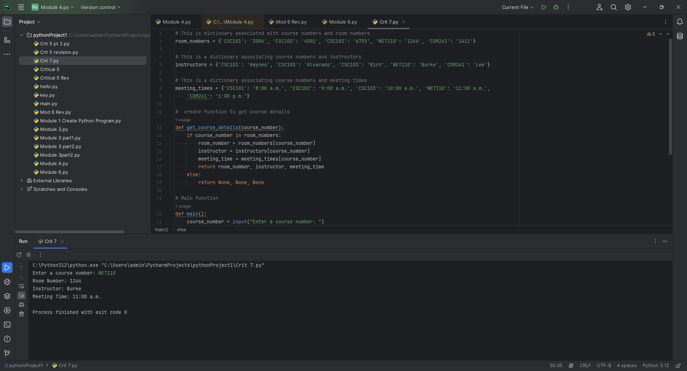

One of the challenges I encountered was closing out the main section of this application. Not

defining the main section receiving a NameError: I kept running variations and

experiments until it was completed resulting in no errors. Otherwise creating the dictionary,

defining and pairing the variables was a pretty straightforward operation.

See below

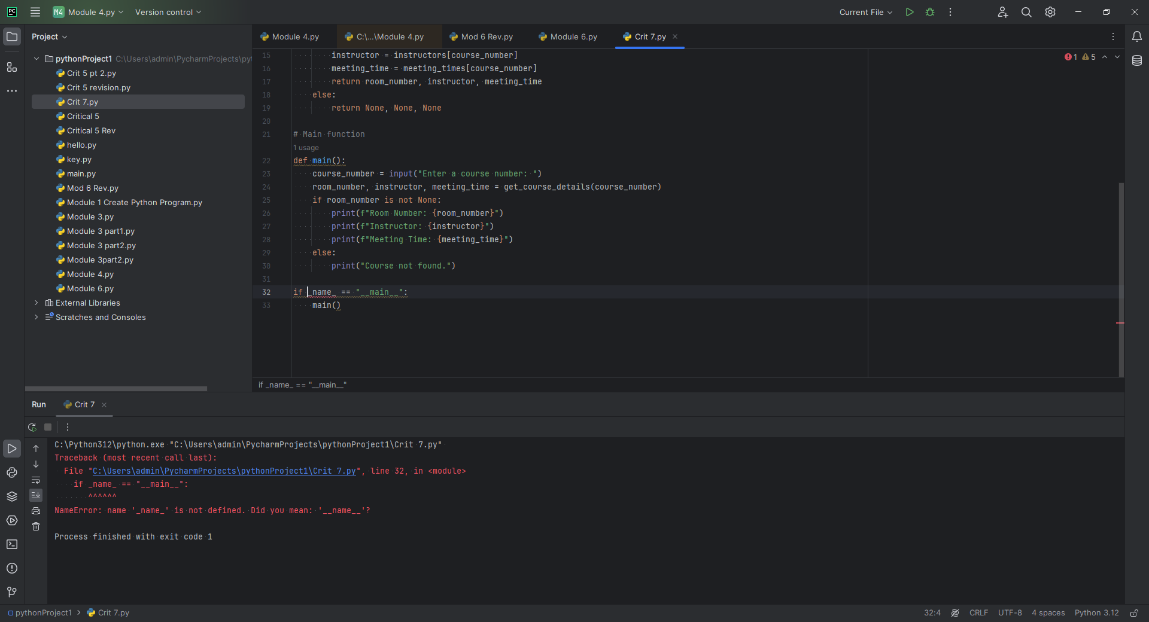

**Pseudocode**

**Step 1:**

**1: DEF** dictionary labeled room numbers  
**2: DEF** dictionary labeled instructors  **3. DEF** dictionary labeled meeting times **4. IF** course number = room number, instructor, meeting time return results in getcourse  **5. ELSE** return none **6. DEF** main section **7. DISPLAY** input from user course number **8. IF** room number is found display room, instructor, and meeting time **9. ELSE** display course not found **1. END** on main condition